CAMPBELLS CANOE LIVERY
1112 Lake Street
Roscommon, MI 48653
(989) 275-5810

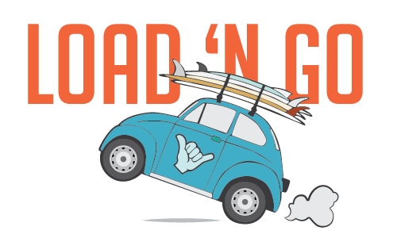
LOAD AND GO
9383 N CUT ROAD
ROSCOMMON, MI 48653

(989) 821-1717

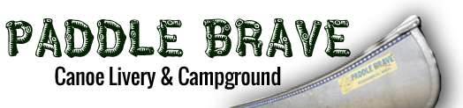

Paddle Brave Camp and Canoe
10610 Steckert Bridge Rd.
Roscommon, MI 48653
Phone: 989-275-5273

