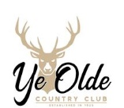
YE OLDE COUNTRY CLUB
904 West Sunset Drive
Roscommon, MI 48653
(989) 275-5582
http://www.yeoldecountryclub.com/

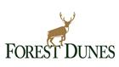
FOREST DUNES
6376 FOREST DUNES DRIVE
ROSCOMMON, MI 48653
PH: 989.275.0700
https://www.forestdunesgolf.com/

